PROJECT REPORT

##### **On**

**News Aggregator**

###### **For**

**Digipodium**

**Towards partial fulfillment of the requirement**

**For the award of degree of**

###### **Bachelor of Computer Applications**

**From**

# Babu Banarasi Das University

**Lucknow**

**Academic Session 2017 - 18**

### School of Computer Applications

PROJECT REPORT

##### **On**

**News Aggregator**

###### **for**

**Digipodium**

**Towards partial fulfillment of the requirement**

**for the award of degree of**

###### **Bachelor of Computer Applications**

**from**

# Babu Banarasi Das University

**Lucknow**

Developed and Submitted by Under Guidance of

Shrish Singh Shubhandra Sir

**Academic Session 2017 - 18**

### School of Computer Applications

# Babu Banarasi Das University.

**Lucknow**

**CERTIFICATE**

###### **This is to certify that Project Report entitled**

News Aggregator

**being submitted by**

**Shrish Singh**

**towards the partial fulfillment of the requirement**

**for the award of the degree of**

###### **Bachelor of Computer Applications**

**to**

# Babu Banarasi Das University

**Lucknow**

**in the Academic Year 2017-18**

**is a record of the student’s own work carried out at**

### Digipodium

**and to the best of our knowledge the work reported herein does not form a part of any other thesis or work on the basis of which degree or award was conferred on an earlier occasion to this or any other candidate.**

#### 

#### Prabhash Ch. Pathak

HEAD (School of Computer Applications

**ACKNOWLEDGEMENT**

We take this opportunity to express our sincere thanks and deep gratitude to all those who extended their whole hearted co-operation and have helped us in completing this project successfully.

Special thanks to all who help and guidance to us in every stage during our project.

Their inspiring suggestions and timely guidance enabled us to perceive the various aspects of the project in a new light.

DECLERATION

I hereby declare that the Final Training report entitled, “News Aggregator” submitted for the BCA degree is my original work and report has not

Formed the basis for the award of any degree, associate ship, fellowship

Or any other similar title.

Signature of student:

Shrish Singh

BCA VIth Semester

Date:27/04/2018

ABSTRACT

Computerized Personal Briefcase is developed to facilitate the users to save and retrieve their personal data whenever and from wherever possible. The helps users access their personal data quickly and easily as and when required, thereby improving his/her operational efficiency & effectiveness. In today’s competitive environment, where everybody wants to be on the top, information plays very crucial role. As fast as information is accessed and processed, it can give good results. Today internet is the fast way of transferring plays very crucial role. As fast as information is accessed and processed, it can give good results. Today internet is the fast way of transferring data and information over wide area , hence I have used internet as way for exchanging information. Computerized system helps to fulfill these goals. Computerization of ability analyzing will help in doing lot of manual work quickly. It will help in easy storage and access of all information, in short period of time.

**TABLE OF CONTENT**

1. Introduction of the Project……………………………………….9

1.1 Introduction

2. Problem Statement…………………………………………………………9

3. Objective……………………………………………………………………9

4.Project Category……………………………………………………………10

4.1. Internet (Web Designing) Including RDBMS

5. System Analysis…………………………………………………………11

6.Identification of Need……………………………………………………12

7.Preliminary Investigations………………………………………………....13

8.Project Planning

9.Feasibility Study……………………………………………………………13

9.1. Technical Study

9.2. Operational Study

9.3. Economical Study

10.Project Schedule………………………………………………....….16

10.1. Gantt Chart………………………………………………………17

10.2. PERT Chart……………………………………………...……….19

11.Software Requirement Specification(SRS)……………....………………20

11.1. Project SRS as Follows

11.2. Administration Section

11.3. User Section

12. Functional Requirement

13. Resources Hardware & Software…………………………………22

13.1. Software Requirement

13.2. Hardware Requirement

14.Tools & Platform

15.Software Engineering Paradigm………………………………………...25

16.The Spiral Model…………………………………………………….26

17. Use Case Diagram

18. High Level Design…………………………………………………………30

18.1. DFD

18.2. 0 Level

18.3. 1 Level

20.E-R Diagram…………………………….………………………………….35

21.system design…………………………………………………………38

22.Project Module……………………………………………………………….39

23.Database Design……………………………………………………….41

24.Use Case diagram…………………………………………………………….43

25. Screen Shots………………………………………………...…………44

26.Test case design…………………………………………...……………76

27.Testing…………………………………………………...…………………….77

28.System Security measure……………………………......……………………85

29.Database security………………………………………….……………87

30.Data Encryption…………………………………………...………………….88

31. Conclusion……………………………………………….……………………89

**Introduction**

* **News aggregator** is a word that comes from RSS Feed Technology**. RSS** (Rich Site Summary) is a type of News web feed.
* Online News aggregator system allows customers to read up to date news related to many fields like Entertainment, National, International, Business, Bollywood, Politics, Sports, Education etc.
* Without any payment. He can also contact us to give suggestions and can also give us feedback related to our site.
* RSS feeds also benefit users who want to receive timely updates from favorite websites or to aggregate data from many news sites.

**Problem Definition**

* Offline newspapers are time consuming and we have to cut off extra time from our daily routine to get the information and news.
* Newspaper are difficult to manage and data is not secure.
* High in cost.
* Lack of variation in the language of content.

**Objective**

* The main objective of this website is to help you to save your time and money.
* The main objective of News aggregator is that to provide the all type of instant and important news related to business world, world sports, national, education etc.
* Those people who don’t have time to read newspaper and always linked with internet can get more informative.
* Provide 24hour available news in my website (News Aggregator).
* We are providing a facility of various languages supporting websites. I.e.-you can read our newspaper any language.

**PROJECT CATEGORY**

Internet (Web Designing) including RDBMS

The project is based on client server architecture. In client server architecture the interface for user is created in any programming language (Front end) and the database where data is stored is called back end. User interface is treated as client to which user request for data and user interface sends the user request to server or database and then server returns the data required by the client program manipulation.

Relational Database Management System (RDBMS) is the most popular and most dominant information management system available today. Commencing in 1971, this concept has proven to be one of the highly prudent ways of storing, retrieving analyzing and managing data. RDBMS provides a set-oriented database language. For most RDBMS, this set-oriented database language is SQL. All information in a relational database (including table and column names) is represented explicitly as values in tables. Every value in a relational database is guaranteed to be accessible by using a combination of the table name, primary key value, and column name. All views that are theoretically updatable can be updated through the system.

RDBMS provide following feature to this project:

•The ability to create multiple relations among tables and store data in it.

•An interactive Query language.

• Retrieval of information form as requirement from tables.

Here client will be application or from end, which will generate request, and the server will be relational database management system which fulfills the request of clients.

**SYSTEM ANALYSIS**

Analysis is a detailed study of the various operations performed by a system and their relationships within and outside of the system. A key question is: What must be done to solve the problem? One aspect of analysis is defining the boundaries of the system and determining whether or not a candidate system should consider other related systems. The main purpose of conducting system analysis is to study the various processes and to find out its requirements. These may include ways of capturing or processing data, producing information, controlling a business activity or supporting management.

System Analysis refers to the process of examining a situation with the intent of improving it through better process and methods. System analysis is, therefore, the process of gathering and interpreting facts, diagnosing problem and using the information to recommend information in system or in other words, it means a detailed explanation or description. Before computerizing a system under consideration, it has to be analyzed. We need to study how it functions currently, what are problems and what are requirements that proposed system should meet.

While the analysis phase of development of this project following set of principles were considered:

•The information domain of a problem must be represented and understood.

•The function that the system has to perform must be defined.

•The behavior of the system must be represented.

•The models that depict information function and behavior must be partitioned in a manner

that uncovers detail in a layered fashion.

• The analysis process should move from essential information towards implementation detail.

System analysis has been conducted with the following objectives in mind:

•Identify the customer needs.

•Evaluate the system concept for feasibility.

•Perform economic and technical analysis.

•Allocate functions to hardware, software, people, data base, and other system elements.

•Establish cost and schedule constraints.

**IDENTIFICATION OF NEED**

Requirement specification provides the developer and the customer with the means to assess quality once software is built. The requirement analysis task is a process of discovery, refinement, modeling, and specification. Requirement analysis allows the developer to refine the system allocation and build models of the data, functional and behavioral domains that will be treated by system.

After detailed study of the identification of needs, following are the requirements of the project that includes:

• New system should not be too costly.

• New system should be fully automated.

• Implementation of the new system should be done in reasonable time.

• New system should be as simple as possible.

• New system should provide new member registration.

• New system should provide direct saving of the webpages in the user’s account.

• New system should provide a facility to keep reminders which can be received personally

through e-mails.

• New system should provide a means to store and edit personal notes.

• New system should provide sharing feature within the website.

• New system should also provide other features like search, edit, delete.

**PRELIMINARY INVESTIGATION**

The purpose of the preliminary investigation is to evaluate project request and determine the feasibility of the system. The preliminary investigation starts as soon as the problem is recognized or a request is initiated to modify the current system. An important outcome of the preliminary investigation is determining whether the system is feasible or not.

The information during the preliminary investigation was gathered through On-Line Observation. During online observation I analyzed similar websites which are related to the News or Updated daily news. All the website provide the facility of reading news but only difference is that “Paper Boy” provides the facility to read news of three different newspaper on a single platform.

**FEASIBILITY STUDY**

A feasibility study is a test system proposal according to its workability, impact on organization, ability to meet users need and effective use of resources. It focuses on the following major questions:

• What are the user’s demonstrable needs and how does he needs them?

• What resources are available for the given system?

• Is the problem worth solving?

• What is the likely impact of the system on the organization?

Each of these questions has to be answered carefully. They revolve around investigation and

evaluation of the problems. Identification and description of candidate systems, specification of performance, cost of each system and the final selection of the best system.

The objective of the feasibility study is not to solve the problem but to acquire a sense of its scope during the study.

The result of the feasibility study is a formal proposal. This is simply a report. A formal document, details the nature and scope of the proposal solution. The proposal summarizes, what’s known and what is going to be done. It consists of the following statement of the problem that leads to the analysis.

➢**Summary of finding and recommendations**: It is a list of major findings and a recommendation(s) of the study. It is the deal for the user who requires quick access to the result of the analysis of the system under study. Conclusions are stated followed by the list of recommendation of the study and a justification for them.

➢**Details of findings**: It is an outline of the methods and procedures undertaken by the existing system followed by the coverage of the objective and procedures of the system. Also the discussion of the output report, file structure and the cost and benefits of the system are included.

➢**Recommendations and conclusions**: It involves specific recommendations regarding the system including personal assignments, costs, project schedules a target data.

Feasibility considerations: Three key considerations are involved in the feasibility analysis:

1. Technical feasibility

2. Operational feasibility

3. Economic feasibility

•**Technical Feasibility**: Technical feasibility is concerned with specifying equipment and software that will successfully satisfy the user requirement. The technical needs of the system may vary considerably, but might   
include:

➢The facility to produce output in a given time

➢Response time under certain conditions

➢ Ability to process a certain volume of transaction at a particular speed

➢Facility to communicate data to distinct location

In examining the technical feasibility, configuration of the system is given more importance than the actual making of hardware. The configuration should provide the complete picture about the systems requirements. How many work stations are required, how these units are interconnected so that they could operate and communicate smoothly.

Considering the above specified points, it is found that the project is technically feasible because minimum hardware and software required in the project is less. These can be acquired quite easily.

The main advantage is that in future if we want to add or change some provision in the system then technically we can do that easily so in this way the current system is technically feasible.

•**Operational Feasibility**: The proposed project is operational feasible due to the following reasons:

➢See U Later is GUI based and hence adds ease of operation to an end user.

➢Since it is laced with many GUI‟s, it provides the desired look to the users along with very simple operational buttons.

➢ It does not need very skilled person. Even a lay man can easily access the website using internet.

➢ Hardly two to three days training is required for the person accessing the database, that is, the Administrator.

•**Economic Feasibility**: The proposed project is economic feasible due to the following reasons:

➢ The number of people required to handle this website is quite less. So this directly reflects to the salaries spend over the employees of the company.

➢ Because of the client server features of this project there is no need to spend money during communication.

**PROJECT PLANNING**

The objective of software project planning is to provide a framework that enables to make reasonable estimates of resources, cost, and schedule. These estimates are made within a limited time frame at the beginning of a project and should be updated regularly as the project progresses. In addition, estimates should attempt to define best case and worst case scenarios so that project outcomes can be bounded Project life cycle has three stages.

**Project Initiation**- The project plan is prepared and the outcome of each phase is finalized. In this stage the comprehensive list of tasks involved in each phase is prepared.

**Project Execution**-The product is developed. This Stage consists of following phases:

Requirement Analysis->High Level Design->Low Level Design->Coding ->Testing ->Acceptance

**Project Completion**- In this stage, the website is updated regularly. When any update or upgrading is required for the website, it is made up to date. There are lots of requirements after the completion of the website, such as replying to the feedback or query.

**PROJECT SCHEDULE**

**•GANTT Chart**

Gantt chart is also known as Time Line Chart. A Gantt chart is a popular type of bar chart that illustrates a project schedule. Gantt charts illustrate the start and finish dates of the terminal elements and summary elements of a project. Terminal elements and summary elements comprise the work breakdown structure of the project.

A Gantt chart can be developed for the entire project or a separate chart can be developed for each function. A tabular form is maintained where rows indicate the tasks with milestones and columns indicate duration (weeks/months). The horizontal bars that spans across columns indicate duration   
of the task.

|  |  |  |  |  |  |  |  |  |  |  |  |
| --- | --- | --- | --- | --- | --- | --- | --- | --- | --- | --- | --- |
| Task | 1Jan-31Jan | 1Feb-21  Feb | | 22Feb-  10Mar | | 11Mar-  11Apr | | 12Apr-  20Apr | | 21Apr-  28Apr | |
| Develop project  proposal | 31 days |  | |  | |  | |  | |  | |
| Analysis |  |  | |  | |  | |  | |  | |
|  |  |
| 21 days | |
| Designing |  |  | |  | |  | |  | |  | |
|  |  |
| 17 days | |
| Coding |  |  | |  | |  | |  | |  | |
|  |  |
| 32 days | |
| Unit Testing |  |  | |  | |  | |  | |  | |
|  |  |
| 9 days | |
| Beta Testing |  |  | |  | |  | |  | |  | |
|  |  |
| 8 days | |

Fig. 1: GANTT Chart for See U Later

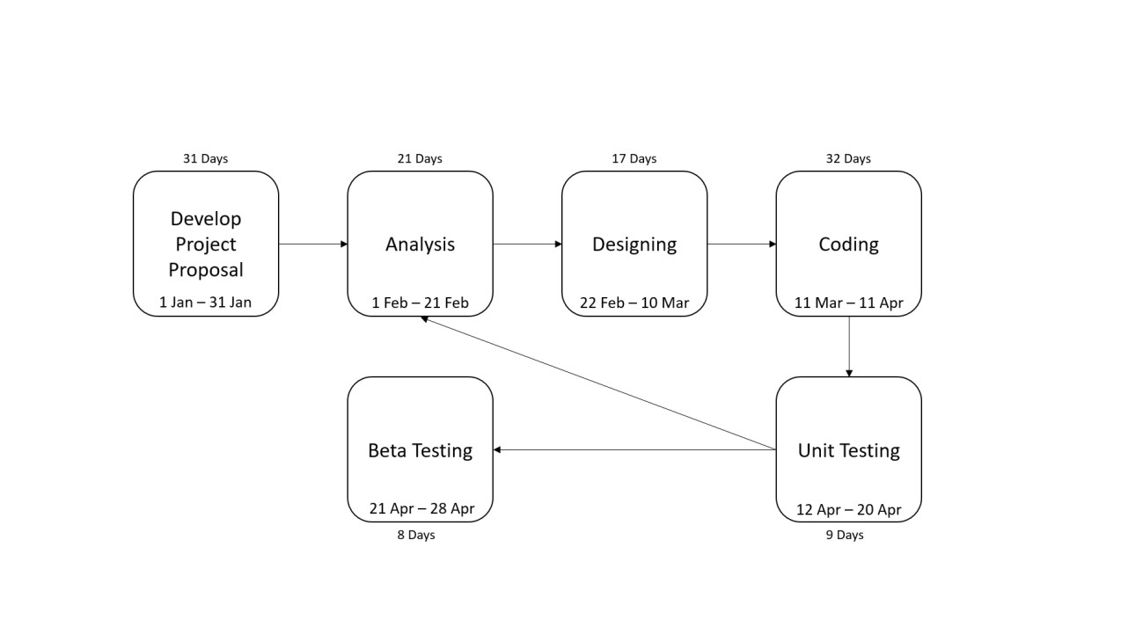

Fig. 2: PERT Chart for See U Later

**• PERT Chart**

PERT stands for Program Evaluation Review Technique. A PERT chart is a project management tool used to schedule, organize, and coordinate tasks within a project. A PERT chart presents a graphic illustration of a project as a network diagram consisting of numbered nodes (either circles or rectangles) representing events or milestones in the project linked by labeled vectors (directional lines) representing tasks in the project. The direction of the arrows on the lines indicates the sequence of tasks.

**SOFTWARE REQUIREMENT SPECIFICATION (SRS)**

SRS is a document that completely describes what the proposed software should do without describing how the software will do it. The SRS is the medium through which the client and the user needs are accurately specified.

**Advantages of SRS:**

•An SRS establishes the basis for agreement between the client and the supplier on what the

software product will do.

•An SRS provides a reference for validation of the final product.

•A high quality SRS is a prerequisite to a high quality software.

•A high quality SRS reduces the development cost.

**Characteristics of an SRS:**

A good SRS is:

1. Correct

2. Complete

3. Unambiguous

4. Verifiable

5. Consistent

6. Ranked for importance and/or stability

7. Modifiable

8. Traceable

**Project’s SRS as follows:**

•Functional Requirement

Functional requirements are those requirements which affect the system and make the system working. It describes what the system should do. Functional requirements of the system are-

➢Registration of the user with unique ID and PASSWORD.

➢ User can change the password or mobile number any time, if required.

➢ User can search, save, delete, share, & access the webpages and notes after login.

➢ User can set notification alerts.

**Administrator section**:

This section can be accessed by providing administrator ID and password. In this section, the admin can view the user information. Admin can view all the reviews and feedbacks sent to him by the users.

**User section:**

Users can register and create their own profiles. After login users can perform different operations and access different services.

**•Non Functional Requirement**

Non-functional requirement describes how system should work or behave. Non-functional requirements of the system are-

**Availability**- The system should be 24/7 available. The customers do not want restrictions on the times when they can access webpages or notes.

**Reliability**- The system should guarantee the reliability to run on any platform or machine and password protected.

**Scalability**-Since the project is planning to increase its customer base, scalability should be assured by the system. The best efforts that can be made consist of enabling multiple customers to access the website at the same time.

**Usability**-The users of the system are not computer experts, and hence particular attention should be paid to usability. Thus, the web interface should be clear, concise, and easy to use.

**Flexibility**- The system should be flexible enough to provide access to the webpages from any machine on any platform at any time.

**Compatibility**-The system should avoid compatibility issues with any system. The system should be compatible to run on any platform.

**RESOURCES (HARDWARE & SOFTWARE)**

**• Hardware Requirements**:

➢Server Side

Processor : Dual Core or above

RAM : 1 GB

Disk Space : 500 GB

Monitor : 15 inch Colour

Keyboard : 108 Key Normal

Mouse : 3 Button Normal Mouse

➢Client Side

Processor : Dual Core or Above

RAM : 1 GB

Disk Space : 500 GB

Monitor : 15 inch Colour

Printer : Depends on User

Keyboard : 108 Key Normal

Mouse : 3 Button Normal Mouse

•**Software Requirements**:

➢ Server Side

• Internet Explorer or Google Chrome

• Windows XP or Above

•Visual Studio 2015

• MS SQL Server 2012

➢ Client Side

• Internet Explorer or Google Chrome

• Windows XP or Above

• MS Office

TOOLS & PLATFORM

This project is a web application that is developed in ASP.NET using C# as front-end tool and having MS SQL Server 2016 as back-end tool.

**• Features of ASP.NET (front-end tool):**

➢ASP.NET is a web application framework to build dynamic websites, web application and web services.

➢ASP.NET is built on the Common Language Runtime (CLR) allowing programmers to write ASP.NET code using supported .NET language.

➢Automatic Handling of Post backs and Multiple Browsers.

➢ ASP.NET has built in navigation controls.

➢ In ASP.NET many security controls are provided.

➢ASP. NET has Intelligence feature that make the coding easy and also dynamic help provides very less coding time.

• Features of MS SQL Server 2016 (back-end tool):

➢Policy-Based Management.

➢ Backup Compressions.

➢ Extending Data Compression in SQL Server 2016 with Fixed Length Data Types.

➢SQL Server includes better compression features, which also helps in improving scalability.

➢ Streamlined installations.

➢ Star Join Query Optimization.

•Library: Select Pdf is used.

**SOFTWARE ENGINEERING PARADIGM**

Software engineering is a layered technology. The foundation for software engineering is the process layer. Software engineering processes the glue that holds the technology layers together and enables ratios and timely development of computer software. Process defines a framework for a set of key process areas that must be established for effective delivery of software engineering technology.

Software engineering methods provide the technical how-tos for building software. Methods encompass a broad array of tasks that include requirements analysis, design, program construction, testing and support. Software engineering tools provide automated or semi-automated support for the process and the methods. When tools are integrated so that information created by one tool can be used by another tool, a system for the support of software development, called computer-aided software engineering is established.

Modular approach is used for developing the proposed system. A system is considered modular if it consists of discrete components so that each component can be implemented separately and a change to one component has minimal impact on other components. Every system is a hierarchy of components. This system is not an exception. To design such hierarchies there are two approaches:

(1) Top down

(2) Bottom up

Both approaches have some merits and demerits. For this system top down approach has been used. It starts by identifying the major components of the system, decomposing them into their lower level components and iterating until the derived level of detail is achieved.

Top down design methods often result in some form of stepwise refinement. Starting from an abstract design, in each step the design is refined to a more concrete level, until we reach a level where no more refinement is needed and the design can be implemented directly. A top down approach is suitable only if the specifications of the system are clearly known and the system development is from scratch.

A bottom up approach starts with designing the most basic or primitive components and proceeds to higher level components that use these lower level components.

**THE SPIRAL MODEL:**

The Spiral Model is widely used in the software industry as it is in sync with the natural development process of any product, i.e. learning with maturity which involves minimum risk for the customer as well as the development firms.

The following pointers explain the typical uses of a Spiral Model −

• When there is a budget constraint and risk evaluation is important.

• For medium to high-risk projects.

• Long-term project commitment because of potential changes to economic priorities as the requirements change with time.

• Customer is not sure of their requirements which is usually the case.

• Requirements are complex and need evaluation to get clarity.

• New product line which should be released in phases to get enough customer feedback.

• Significant changes are expected in the product during the development cycle.

**REASONS BEHIND USING SPIRAL MODEL**

•Since there is no existing system (computerized), prototyping model is an attractive idea.

•It helps to reduce the cost and time.

•It provides an early detection of errors.

•It allows the developers to have a greater control over the problem.

•It is an effective method of demonstrating the feasibility of a certain approach.

•Exposes developers to potential future system enhancements.

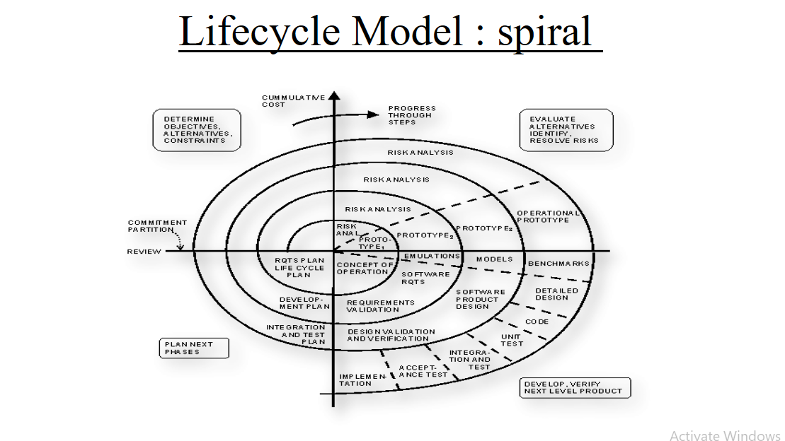

**DATA MODEL**

A data model is an [abstract model](http://en.wikipedia.org/wiki/Abstract_model) that describes how [data](http://en.wikipedia.org/wiki/Data_(computing)) is represented and accessed. The term Data flow diagram is graphical representation of flow of data in an information system. It is capable of depicting incoming data flow, outgoing data flow and stored data. The DFD does not mention anything about how data flows through the system. DFD depict flow of data in the system at various levels. DFD does not contain any control or branch elements

data model has two generally accepted meanings:

1. A data model theory, i.e. a formal description of how data may be structured and accessed.

2. A data model instance, i.e. applying a data model theory to create a practical data model instance for some particular application.

Data Model Theory: A data model theory has three main components:

➢The structural part: a collection of data structures which are used to create databases representing the entities or objects modelled by the database.

➢The integrity part: a collection of rules governing the constraints placed on these data structures to ensure structural integrity.

➢The manipulation part: a collection of operators which can be applied to the data structures, to update and query the data contained in the database.

Data Model Instance

A Data Model Instance is created by applying a Data Model Theory. This is typically done to solve some business enterprise requirement.

Business requirements are normally captured by a semantic [logical data model.](http://en.wikipedia.org/wiki/Logical_data_model) This is transformed into a physical Data Model Instance from which is generated a physical [database.](http://en.wikipedia.org/wiki/Database)   
For example, A Data Modular may use a data modelling tool to create an Entity-relationship model of the [corporate data repository](http://en.wikipedia.org/wiki/Corporate_data_repository) of some business enterprise. This model is transformed into a [relational model,](http://en.wikipedia.org/wiki/Relational_model) which in turn generates a relational database.

**Use Case Diagram**

**Write Brief Description**

**DATA DICTIONARY**

Data dictionary is the centralized collection of information about data. It stores meaning and origin of data, its relationship with other data, data format for usage, etc. Data dictionary is often referenced as meta-data repository. It is created along with DFD model or software program and is expected to be updated whenever DFD is changed or updated.

**(ER-Diagram)**

**Entity Relationship Diagram**

Entity-Relationship model is a type of database model based on the notion of real world entities and relationship among them. ER model creates a set of entities with their attributes, a set of constraints and relation among them. ER model is best used for the conceptual design of database.

Symbols of ER Diagram

NAME SYMBOL DESCRIPTION

Entity An entity is a real world object such as

person, organization.

Relationship Relationships is the logical association

Among entities. Relationships are

Mapped with entities in various

Ways.

Attribute Attributes are some of the properties of the

entity.

Identifier Attribute All the attributes that are primary key should

be written in the Identifier attribute box.

Multivalued Attribute All the Multivalued attributes written in the

Multivalued Attributes

Mapping Cardinality- Mapping cardinalities define the number of associations between two entities. Mapping cardinalities:

•One-to-One

•One-to-Many   
•Many-to-One

•Many-to-Many

**ER diagram**

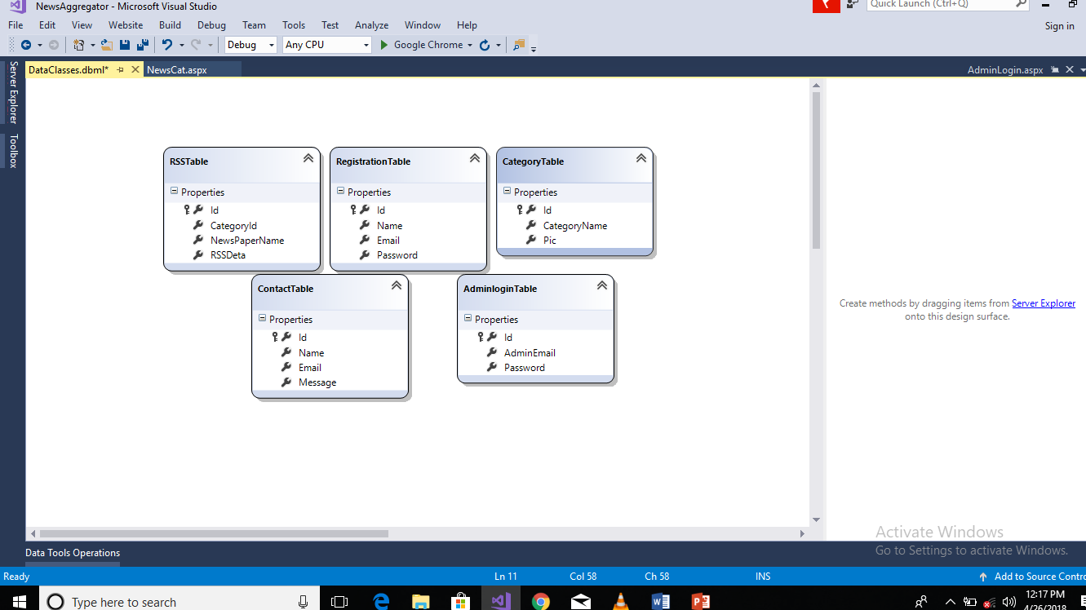

Fig. 7: Class Diagram for News Aggregator

**SYSTEM DESIGN**

The design of the system is the most critical factor affecting the quality of the software; it has major impact on the later phases, particularly testing and maintenance. The output of this phase is the design document. This document is similar to blueprint or plan for the solution.   
The design activity is often divided into two phases: -

❖ System Design

❖ Detailed Design

System design aims to identify the modules that should be in the system, the specifications of these modules and how they interact with each other to produce the desired results. At the end of system design all the major data structures, file formats and the major modules in the system and their specifications are decided.

During Detailed Design, the internal logic of each of the modules specified in system design is decided. During this phase further details of the data structures and algorithmic design of each of the modules is specified. The logic of a module is usually specified in a high-level design description language, which is independent of the target language, in which the software will eventually be   
implemented.

**Project Modules:**

* **Account system** - Login using cloud authentication system, Gmail authentication system or Facebook Login.
* **RSS feed Technology** – RSS (Rich Site Summary; originally RDF Site Summary; often called Really Simple Syndication) is a type of web feed which allows users to access updates to online content in a standardized, computer-readable format.
* **Category Management -** It is a Function that Manages the given categories according to the user’s interest.
* **Gallery management** – In the news aggregator gallery inside the different type of newspaper news data in a single website.
* **Notification System** - if you want a news aggregator that focuses on real-time feed notifications and leaves out all the other stuff that comes with most news readers.
* **Reviews & Rating** – In news aggregator Review Command does not charge a subscription, and does not store your account passwords in the cloud like online services do. It supports reviews from IOS App Store, Google Play, Mac, Windows Store, and Amazon App Store.
* **Reminder system –** It is a framework in an application which enable the user to search the data (audio) according to their purpose. It can achieve by creating the search dialogue which can deliver the users search query to specific activity in your application.
* **Admin dashboard –**This plug in shows latest news in the Word Press Admin Dashboard from the RSS feed URL that you provide**.**

This plug in helps to show your latest news in the Word Press Admin Dashboard via an RSS feed.

* **Search System -**It is a framework in an application which enable the user to search the Multiple news data according to their purpose. It can acheive by creating the search all news in single website which can deliver the users search news to specific activity in your application.
* **Sharing system** - It is a system in which developers give their users a prompt to share the app with other people, specifically those in their Google Contacts registry. At the moment these invitations can go out over email or SMS. This will send a "deep link" to the Play Store, and if the developer enables it, a promotional bonus for the new user.

**DATA INTEGRITY AND CONSTRAINTS**

**Data Integrity**:

The relational database model includes two general integrity rules. These integrity rules implicitly or explicitly define the set of consistent database states, or change of states, or both. There are following type of integrity rules:

**• Entity Integrity**: It states that “If the attribute A of relation R is a prime attribute of R, then

A cannot accept null values. In my project I have maintained the entity integrity by making it sure that no primary key has null value.

**• Referential Integrity**: It can be stated as: “Given two relations R1 and R2, suppose R1 refers

to the relation R2 via a set of attributes that forms the primary key of R2 and this set of attributes forms a foreign key in R1. Then the value of the foreign

key in a tuple R1 must either be equal to the primary key of a tuple of R2 or be entirely NULL.”

**Data Constraints**:

Constraints are the rules enforced on the data columns of a table. They are used to limit the type of data that can go into a table. This ensures the accuracy and reliability of the data in the database. Constraints could be either on a column level or a table level. The Column level constraints are applied only to one column, whereas the table level constraints are applied to the whole table.

**The Primary Key Constraint**: The primary key constraint enforces Entity Integrity, which requires each row to have a unique identifier, so that data modifications or queries always refer to a specific row without ambiguity. It requires each row in that column to have a not null, unique value.

**The Unique Constraint**: The unique constraint enforces uniqueness in a column or combination of column. It also enforces uniqueness by building an index on the designated column or columns.

**The Foreign Key Constraint**: The foreign key constraint defines the relationship between a column or combination of columns in the current table and a column or combination of columns in another table. In other words, it enforces Referential Integrity.

**The Not Null Constraint**: The not null constraint ensures that a column cannot have null value.

**DATABASE DESIGN**

A database may be thought of as a set of related files. Related files mean that record of one file may be associated with the records in another file. The conventional file based systems emphasized that the application and files were built around it. The database environment emphasizes the data independently of the applications that use the data.

The applications are allowed to evolve around a database design such that it can adapt to changing needs. Data becomes the central resource in the database environment. Information systems are built around this central resource to give flexible access to data. Special software called Database Management System often referred to, as backend is required to control the database operations. The three different approaches to build the databases are: Hierarchal Database Management System, Network Database Management System and Relational Database Management System.

**Database Table**

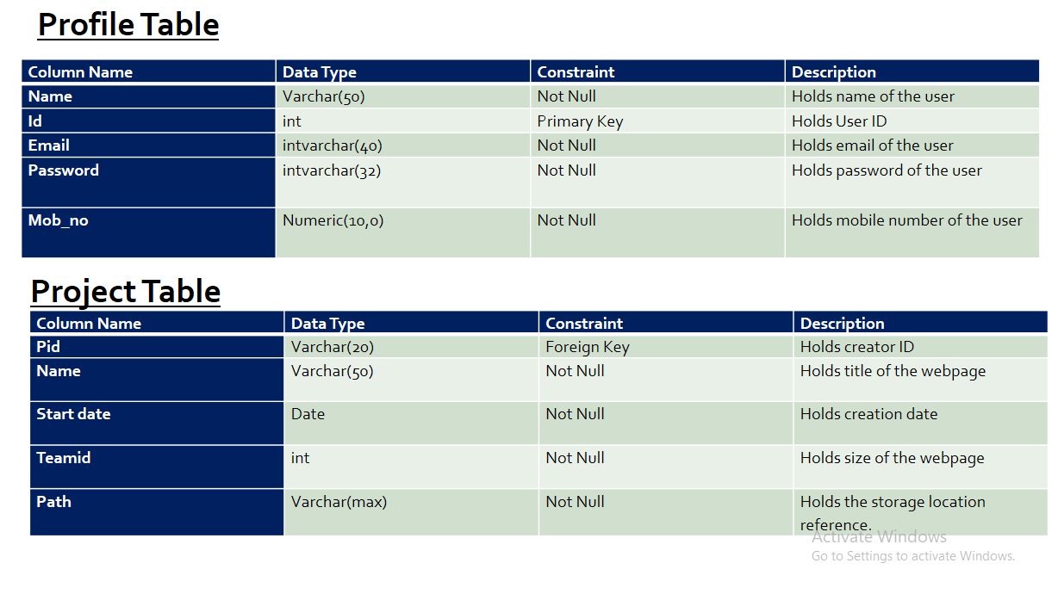

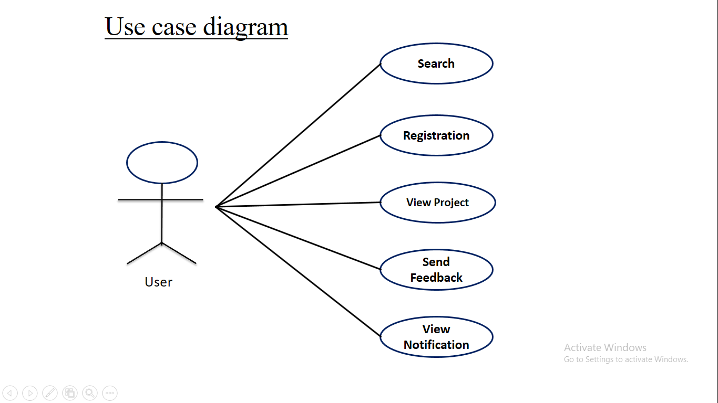

**NEWS AGGREGATOR INTERFACE DESIGN**

**Home Page**

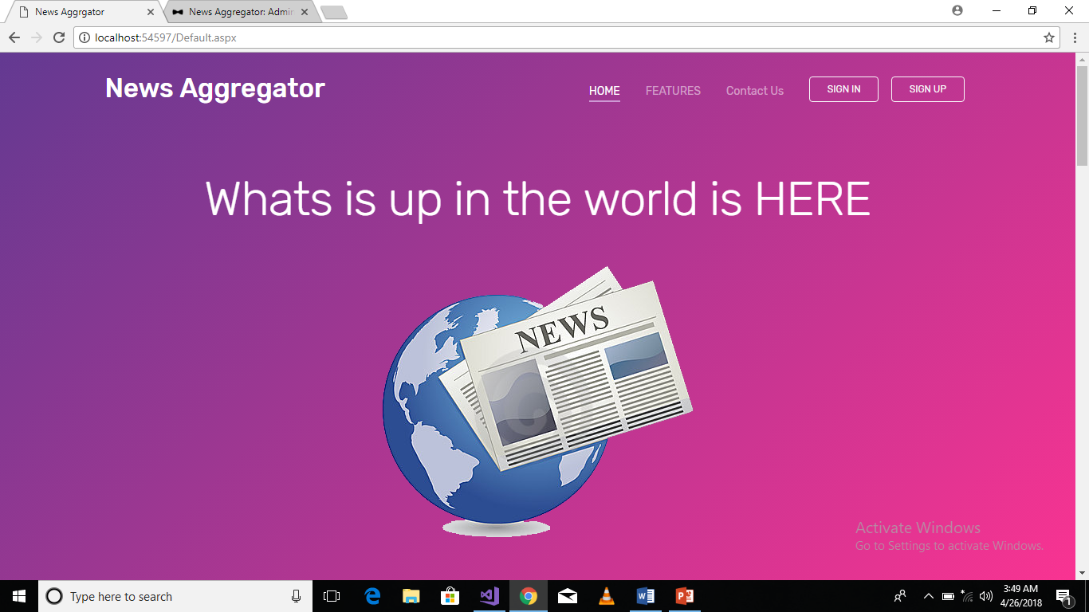

**TEST CASE DESIGN**

Thorough testing is required to run the project at client end successfully. I prepared a number of test cases and input data from the developed project and saw their impact in the final reports for example.

Test Case I

All the fields are entered with the correct values in the Registration form on the website. On clicking Sign up, all the data must be stored in Accounts table. The test is successful.

Test Case II

In the login form, entering correct username with wrong password must display the message for writing correct credentials. The test is successful.

Test Case III

In the user panel, searching the webpage with two letters must display all the webpages containing those two letters together in the heading. The test is successful.

Test Case IV

In the user panel, while setting an alert, if the date or time is being set for the expired time, an error must pop-up displaying to choose correct time/date. The test is successful.

**TESTING**

Software testing is a critical element of software quality assurance and represent the ultimate review of specification, design, coding. The purpose of product testing is to verify and validate the various work products viz. units, integrated unit, final product to ensure that they meet their requirements.

In software development phase and error can be injected at any stage during development, so, the different type of testing is required on different levels. For using all levels of testing which are essential to test client needs, requirements, design and coding, we have to follow different type of   
methods of testing to test the different stages of development. Software Testing is the process of testing the software project. Effective software will contribute to the delivery of higher quality software products, more satisfied users, lower maintenance costs, more accurate, and reliable results.

**TESTING TECHNIQUES AND TESTING STRATEGIES**

Basically, testing is done for the following purposes:

•Testing is a process of executing a program with the intent of finding an error.

•A good test case is one that has a high probability of finding undiscovered errors.

•A successful test case is one that uncovers yet undiscovered error.

Our objective is to design test cases that systematically uncover different classes of errors and do so with a minimum amount of time and effort. This process has two parts:

➢**Planning**: This involves writing and reviewing unit, integration, functional, validation and acceptance test plans.

**➢ Execution**: This involves executing these test plans, measuring, collecting data and verifying if it meets the quality criteria. Data collected is used to make appropriate changes in the plans related to development and testing.

The quality of a product or item can be achieved by ensuring that the product meets the requirements by planning and conducting the following tests at various stages.

**Verification and Validation**

Software testing is used in association with verification and validation:

➢**Verification:** Have we built the software right (i.e., does it match the specification?)? It is process based.

➢**Validation:** Have we built the right software (i.e., is this what the customer wants?)? It is product based.

**TYPES OF TESTING**

The main types of software testing are:

• **Unit Testing**: Starting from the bottom the first test level is Unit Testing (Component

testing). It involves checking that each feature specified in the “Component Design” has been implemented in the component. In theory an independent tester should do this, but in practice the developer usually does it, as they are the only people who understand how a component works. The problem with a component is that it performs only a small part of the functionality of a system, and it relies on co-operating with other parts of the system, which may not have been built yet. To overcome this, the developer either builds, or uses special software to trick the component into believing it is working in a fully functional system.

• **Interface Testing**: As the components are constructed and tested they are then linked

together to check if they work with each other. It is fact that two components that have passed all their tests, when connected to each other produce one new component which may be full of faults. These tests can be done by specialists, or by the developers. Interface testing is not focused on what the components are doing but on how they communicate with each other.

The tests are organized to check all the interfaces, until all the components have been built and interfaced to each other producing the whole system.

**• System Testing**: Once the entire system has been built then it has to be tested against the

“System Specification” to check if it delivers the features required. It is still developer focused, although specialist developers known as system testers are normally employed to do it.

In essence System testing is not about checking the individual parts of the design, but about checking the system as a whole. In effect it is one giant component. System testing can involve a number of specialist types of test to see if all the functional and non-functional requirements have been met. In addition to functional requirements these may include the following types of testing for the non-functional requirements:

1**). Performance**- Are the performance criteria met?

2). Volume- Can large volumes of information be handled?

3). Stress- Can speaks volumes of information be handled?

4). Documentation- Is the documentation usable for the system?

5). Robustness- Does the system remain stable under adverse circumstances?

**• Acceptance Testing**: Acceptance testing checks the system against the “Requirements”. It is

similar to system testing in that the whole system is checked but the important difference is the change in focus: System testing checks that the system that was specified has been delivered. Acceptance testing checks that the system delivers what was requested. The customer and not the developer should always do acceptance testing. The customer knows what is required from the system to achieve value in the business and is the only person qualified to make that judgment. The forms of tests may follow those in system testing, but at all times they are informed by the business needs.

•**Release Testing**: Even if a system meets all its requirements, there is still a case to be

answered that will it benefit the business? Release testing is about seeing if the new or changed

system will work in the existing business environment. Mainly this means the technical

environment, and checks concerns such as:

1. Does it affect any other systems running on the hardware?

2. Is it compatible with other system?

3. Does it have acceptable performance under load?

**TEST CASE DESIGN**

Test case design focuses on a set of techniques for the creation of test cases that meet overall testing objectives. In test case design phase, the engineer creates a series of test cases that are intended to “demolish” the software that has been built.

Any software product can be tested in one of two ways:

1). Knowing the specific function that a product has been designed to perform, tests can be conducted that demonstrate each function is fully operational, at the same time searching for errors in each function. This approach is known as Black Box Testing.

2). Knowing the internal workings of a product, tests can be conducted to ensure that internal operation performs according to specifications and all internal components have been adequately exercised. This approach is known as White Box

**Testing.**

**Black box testing**:

Black box testing is designed to uncover errors. They are used to demonstrate that software functions are operations; that input is properly accepted and output is correctly produced; and that integrity of external information is maintained. A black box examines some fundamental aspects of a system with little regard for the internal logical structure of the software.

**White box testing**:

White box testing of software is predicated on close examination of procedural details. Providing test cases that exercises specific set of conditions and/or loops, tests logical paths through the

software. The “state of program” may be examined at various points to determine if the expected or asserted status corresponding to the actual status.

|  |  |  |  |  |  |  |  |  |
| --- | --- | --- | --- | --- | --- | --- | --- | --- |
| TEST REPORTS | | | | | | | |  |
| Test Case  ID | Test  Requirements | Test for the  Features | Steps to be  Executed | Expected  Result | Actual Result | Pass  / Fail | Bug |
| Sign in |  |  |  |  |  |  |  |
| TC001 | Login as user | Login field | 1. Enter the  Invalid  Username and  Valid Password.  2. Click Sign in  button. | Message  Invalid  Username or  Password  should be  displayed. | Message  Invalid  Username or  Password is  displayed. | Pass |  |
| TC002 | Login as user | Login field | 1. Enter the  Valid Username  and Invalid  Password.  2. Click Sign in  button. | Message  Invalid  Username or  Password  should be  displayed. | Message  Invalid  Username or  Password is  displayed. | Pass |  |
| TC003 | Login as user | Login field | 1. Enter the  Valid Username  and Valid  Password.  2. Click Sign in  button. | Home page of  the User panel  should be  displayed. | Home page  of the User  panel is  displayed. | Pass |  |
| Name |  |  |  |  |  |  |  |
| TC004 | Valid name  entry | Registration  field | 1. Enter the name  with number.  2. Click Sign up  button. | Message Use  only alphabets  should be  displayed. | Message Use  only  alphabets is  displayed. | Pass |  |
| E-mail |  |  |  |  |  |  |  |
| TC005 | Valid e-mail  entry | Registration  field | 1. Enter the e-  mail with invalid  expression.  2. Click Sign up  button. | Message  Invalid e-mail  should be  displayed. | Message  Invalid e-  mail is  displayed. | Pass |  |
| Username |  |  |  |  |  |  |  |
| TC006 | Valid username  entry | Registration  field | 1. Enter the  existing  username.  2. Click Sign up  button. | Message  Username  already exists  should be  displayed. | Message  Username  already exists  is displayed. | Pass |  |
|  | | | | | | | |

**DEBUGGING AND CODE IMPROVEMENT**

In ideal worlds, all programmers would be so skilled and attentive to detail that they would write bug-free code. Unfortunately, we do not live in an ideal world. As such, debugging, or tracking down the source of errors and erroneous result, is an important task that all developers need to perform before they allow end-user to use their applications. Some techniques for reducing the number of bugs in code up front.

There are three categories of bugs:

**Syntax error**:

These errors occur when code breaks the rule of the language, such as a forgotten closing curly braces ({}) in c#. This error is the easiest to locate. The language complier or integrated development environment (IDE) will alert the coder to them and will not allow to compile the program until it is corrected.

Semantic error:

These errors occur in code that is correct according to rules of the compiler, but that causes unexpected problems such as crashes or hanging on execution. A good example is code that execute in a loop but never exists the loop, either because the loop depends on the variable whose values was expected to be something different than it actually was or because the programmer forget to increment the loop counter. Another category of errors in this area includes requesting a field from a dataset, there is no way to tell if the field actually exists at compile time. These bugs are harder to detect and are one type of running error.

Logic error:

Logic errors are like semantic errors logic errors are runtime error. That is, they occur while the program is running. But unlike semantic errors, logic errors do not cause the application to crash or hang. Logic error results in unexpected values or output. This can be a result of something as simple as a mistyped variables name that happens to match another declared variable in the program. This type of error can be extremely difficult to track down to eliminate.

Preventing Debug Write readable code

Develop and make consistent use of naming and coding standards. It not that important which standard we use, such as Hungarian notation or Pascal, Casing (First Name) or other naming conventions, as long as we use one. We should also strive for consistency in our comments and encourage liberal commenting code.

**Create effective test plan**

The only effective way to eliminate logic error is to test very path of your application with every possible data values that a user could enter. This is difficult to manage without effective planning. We should create our test plan at the same time we are designing the application, and we should update these plans as you modify the application design

**SYSTEM SECURITY MEASURES**

Computer systems face a number of security threats. One of the basic threats is data loss, which means that parts of a database can no longer be retrieved. This could be the result of physical damage to the storage medium (like fire or water damage), human error or hardware failures.

Another security threat is unauthorized access Many computer systems contain sensitive information, and it could be very harmful if it were to fall in the wrong hands. Imagine someone getting a hold of your social security number, date of birth, address and bank information. Getting unauthorized access to computer systems is known as hacking. Computer hackers have developed   
sophisticated methods to obtain data from databases, which they may use for personal gain or to harm others.

A third category of security threats consists of viruses and other harmful programs. A computer virus is a computer program that can cause damage to a computer's software, hardware or data. It is referred to as a virus because it has the capability to replicate itself and hide inside other computer files.

The objective of system security is the protection of information and property from theft, corruption and other types of damage, while allowing the information and property to remain accessible and productive. System security includes the development and implementation of security countermeasures.

The system security problem can be divided into four related issues-

➢ Security

➢ Integrity

➢ Privacy

➢ Confidentiality

•**System security**: Refers to the technical innovations and procedures applied to the hardware

and operating systems to protect against deliberate or accidental damage from a defined threat. In contrast data security is the protection against data from loss disclosure, modification and destruction.

• **System integrity**: Refers to the proper functioning of hardware and programs, appropriate

physical security, and safe against external threats such as eavesdropping and wire-tapping. In contrast data integrity make sure that data do not differ from their original form and have not been accidentally or intentionally disclosed, altered or destroyed.

**• Privacy**: Defines the rights of the users or organizations to determine what information they

are willing to share with or accept from others and how the organization can be protected against unwelcome, unfair or excessive dissemination of information about it.   
• **Confidentiality**: Confidentiality is a special status given to sensitive information in a database to minimize possible invasion of privacy. It is an attribute of information that characterizes its need for protection.

**Control Measures**:

After system security risks have been evaluated, the next step is to select the measures that are internal and external to the facility. The measures are generally classified under the following:

**• Access Control**: Various steps are taken to control access to a computer facility. One way is

to use an encoded card system with a log-keeping capability. Encryption is an effective and practical way to safeguard data transmitted over an unprotected communications channel.

• **Audit Controls**: It protects a system from external security breaches and internal fraud or

embezzlement. The resources invested in audit controls, however should balance with the sensitivity of the data being manipulated. One problem with audit controls is that it is difficult to prove their worth until the system has been violated or a company officer imprisoned. For this reason, audibility must be supported at all management levels and planned into every system.

**DATABASE SECURITY**

Much attention has been focused on network attacks by crackers, and how to stop these. But the vulnerability of data inside the database is somewhat overlooked. Databases are far too critical to be left unsecured or incorrectly secured.

Most companies solely implement perimeter-based security solutions, even though the greatest threats are from internal sources. And information is more often the target of the attack than network resources.

Securing a database allows organizations to protect the corporate data from threats from external sources. Database Security is a serious issue, and if not implemented correctly, the consequences can be costly to companies if their vital data is hacked into, or their customer's data "leaks" out which can even lead to cases of identity theft.

The best security practices protect sensitive data as it's transferred over the network (including internal networks) and when it's at rest. One option for accomplishing this protection is to selectively parse data after the secure communication is terminated and encrypt sensitive data   
elements at the SSL/Web layer. Doing so allows enterprises to choose at a very granular level (usernames, passwords and so on.) the sensitive data to secure throughout the enterprise.   
Application-layer encryption and mature database-layer encryption solutions allow enterprises to selectively encrypt granular data into a format that can easily be passed between applications and databases without changing the data.

**Data Encryption:**

The sooner data encryption occurs, the more secure the information is. Due to distributed business logic in application and database environments, organizations must be able to encrypt and decrypt data at different points in the network and at different system layers, including the database layer. Encryption performed by the DBMS can protect data at rest, but you must decide if you also require protection for data while it’s moving between the applications and the database and between different applications and data stores. Sending sensitive information over the Internet or within your corporate network as clear text defeats the point of encrypting the text in the database to provide   
data privacy.

**CONCLUSION**

From this project This is the promised follow-up to my recent piece: “using news aggregators". With the help of quite a few of you (thanks a lot to you all!!) and by continuing my never ending search for more News information sources I have compiled what I think is a decent list of alternative and/or quality information sources. As I mentioned it in my previous piece, these information sources are contained in a so-called RSS Technology which can be imported into an "RSS news aggregator" or "news reader**".** I hope that this learning Project has increased your understanding of News aggregator and has allowed you to consider using them in your life**.**  No matter what the subject you are interested in, chances are there is a News aggregator for it.